TRIP TO BUDAPEST & Bratislava

1) Meeting point for the departure from Brno:
Thursday, June 9, 6.45 am at the Lobby of the residence.

2) Meeting point for the departure for transfer from Budapest to Bratislava:
Saturday, June 11, 8.00 am (We should be reaching Brno around 10 pm)

3) Accommodation: We will stay in the Fortuna Boat Hotel***, where towels, soaps, two breakfasts and lunch on Friday will be provided. The available rooms are as follows:

9 x double rooms with shower and toilet
3 x triple rooms with shower and toilet

4) Money: Coach to and from Budapest, hotel and 2 breakfasts are paid for you, but you will need some money for entrance fees to museums and baths, meals and traveling around Budapest. The Hungarian currency is “Forint“ (HUF) and the current exchange rates are:

1 CZK = 10,97 HUF
1 CAD = 185 HUF
1 EUR = 265,7 HUF

We will exchange money (or withdraw from ATM) once we arrive to the city. You are looking at spending something between 10000-30000 HUF, depending on your living standard. You can get a meal for 1000-3000 HUF, beer for 350-600 HUF, if you are not afraid of walking, you will be fine with buying only couple of tram tickets, etc. Visit http://www.eurocheapo.com/budapest/features/budget-tips-budapest.html to learn how to safe some forints…

5) Weather: The weather forecast for the relevant days is very ambiguous. Expect sunny and hot moments with rains and thunderstorms. The temperature will vary between 24°C during days and 14°C at nights. For details see: http://news.bbc.co.uk/weather/forecast/59?&search=budapest&itemsPerPage=10&region=world

6) Budapest it the largest spa city, and we’ll go to one of the spas on Friday night (and may be to another one at a different point), so don’t forget to pack the swimming suite! You might consider taking also a towel, as we’ll go to the spa after we check out from the hotel. The visit to the spa won’t be obviously mandatory.

7) Passport: Please, take your passport! Bring also you international student card (if you have one), as you can apply for significant discounts when buying tickets to museums, galleries…

BUDAPEST & BRATISLAVA TRIP (9-11 June, 2011)

Your guides: Jeff Taylor (Budapest), Michal Vasecka (Bratislava)

Thursday
6.50 meeting at the lobby of Residence
7.00 departure to Budapest (bus)
approx. 12.00 arrival to Budapest, Fortuna Boat Hotel (Szent István rakpart, http://www.hotels-in-budapest-hungary.com/fortunaboathotel.php)

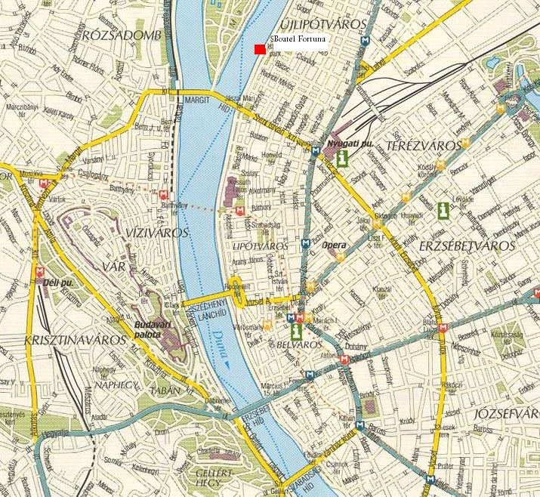

12:45 Transfer to the West (Nyugati) Railway station – exchanging money, buying tickets, lunch and transfer to the Castle
15:00 First sightseeing tour (about 3 hours): by tram to Moszkva tér – Buda castle – Fisherman's Bastion, Matyás Templom, Royal Palace – Chain Bridge (Lánchíd) – St. István (Stephen) Basilika – Andrassy ut

Evening:
- Climbing up the Gellert Hill (great view of the city)
- Going to a “kert”, club …

Friday
8:00-9:15 Breakfast
9:30: Second tour (estimated time 4 hours) Országház (Hungarian Parliament Building) – Szabadság tér – Deák Ferenc tér – Vörösmarty tér – Vigado – Danube Embankment – Vaci utca - Dohány Synagogue (the largest synagogue in Europe) – visit to the House of Terror.

Free afternoon – suggestions either bellow or upon request from Jeff or me. Alternatively, we can go to

Suggestion for the afternoon:
- Holocaust Memorial Centre of Budapest (39 Páva utca – blue metro [M3] stop Ferenc korut) – admission: 1200 HUF, free for students with valid international student card
- Széchényi Bath (it is unique to the city, sort of inexpensive [2000 - 2400 HUF], it includes several indoor/outdoor pools, steam/dry sauna, massage, etc.)
- Central Market Hall
- Visit to the Hero Square and City Park

Evening: Night bathing at the Rudas Bath – on Fridays and Saturdays between 10:00 PM and 4:00 AM you can relax and have fun in the oldest Budapest bath, which was built by the Ottomans. During the ordinary opening hours only man are allowed to visit the bath (with the exception of Tuesdays, when bath is reserved strictly for woman), but the weekend nights are open for both genders. Great experience!

Saturday
7:00-7:45 Breakfast
8:00 Departure from Budapest to Bratislava (approx. 2.5 hours)
11:00-13:15 Lecture by Michal Vasecka (the first session of the Module 3)
13:30-14:30 Lunch
14:30-16:00 Tour to the castle and downtown Bratislava
16:00-18:00 Free time in Bratislava
18:00-21:30 Visit to the wine cellar
Approx. 23:00 Arrival to Brno

Budapest must do:
1) Go to baths (Széchényi is scheduled for Sunday afrernoon but there are many others, such as Gellért, Lukács, Király – for more info on Budapest baths click here)
DON’T FORGET THE SWIMSUIT!
2) Enjoy the night sight from the Gellert Hill
3) Walk through the Jewish quarter of the city
4) Have a cake at Gerbeaud at Vorosmarty ter.
5) Go to see mummified right hand of St. Istvan – Stephen (the founder of the Hungarian state) in the back of St. Istvan basilika
6) Buy a bottle of Tokai Wine (Hungarian speciality)
7) Try Hungarian Goulash
8) Have a rest in the biggest park – Margarit's Island
9) Look for art noveau architecture (Gresham Palace, ZOO entrance, Hotel Gellert, …)
10) Have a beer in one of Budapest’s “kerts” (E.g. Szimpla kert at Kazinczy utca 14 or Mumus at Dob utca 18)
11) Visit a Central Market Hall
12) Visit Holocaust Memorial Centre of Budapest

Budapest could do:
1) Try Unicum
2) Go to Old Man’s pub at 3 am
3) Go to see the iron statue of Karl Marx in the Budapest school of Economics
4) Visit the Buda Castle Labyrinth
5) If you are Roman history obsessed, visit Aquincum
6) Visit the Buda hills and climb up János hegy
7) If you liked the Moravian Kars caves (the first trip), visit also the Buda caves
8) Visit a ZOO – the architecture is particularly interesting
9) Go to Vidampark – perhaps the best amusement park across the iron curtain
10) Visit a Statue Park – warehouse of old communist statues, which were removed after 1989

Suggestions for the evening:

Chachacha Terasz Budapest (Margit Island open air)
Fészek Klub: VII, Kertész utca 36.
Kiskacsa: VII, Dob utca 26. (Deák tér, M1/2/3)
Szimpla & Dupla: VII, Kertész utca
Kuplung: VI. Király utca 46,
Liszt Ferenc tér (bars & clubs: Cafe Mediterán, Fortuna Bistro),
Asztoria, the main ring (korut), or Váci utca you can’t go wrong.
Martinez: VII, Dohány utca 1, across from the Dohány synagogue.
Old Man’s pub: VII, Akácfa utca 13.
Szimpla Kert: Kazinczy utca 13 (outdoor courtyard bar and club)
Paris, Texas: IX Ráday utca 22
Open air dancing places: 1) Between the Erszébeth bridge and the Rudas bath. 2) On the Buda side of the Petöfi Bridge is a cluster of outdoor dance clubs, right on the river: the Zöld Párdon (XI. Goldmann György tér, www.zp.hu) and adjacent Café Del Rio, and the A38 boat (www.a38.hu). 3) For more check this: http://www.budapestagent.com/open-air-clubs-in-budapest.html

Restaurants: http://www.budapest-tourist-guide.com/cheap-restaurants-in-budapest.html or http://www.budapestsun.com/restguide.asp

Opera: http://opera.hu/index.php?module=main – there are still tickets available for the selection of ballet performance on Thursday night and the Snow White and the Il barbiere di Siviglia (opera) by Rossini on Friday night. You can get ticket for so little as 500 HUF.

10-DAY Calendar with useful information: http://www.xpatloop.com/events/?d=2011-06-09 and http://www.jegymester.hu/eng/Timetable/Idorend

Shopping: There are many better things to do in Budapest than shopping, but if you can’t do without it, than visit West End City Center by the Nyugati pályaudvar (West train station) or Mammut at Moszkva tér. As for souvenirs, go to the Central Market Hall or to Vaci utca at Pest downtown.

Public transport info: http://www.bkv.hu/english/home/index.html
Single non-transferable 320 HUF
Transfer ticket 490 HUF
10-rides 2800 HUF (can be shared by more people who have to however travel together)
24-hour-pass 1550 HUF
72-hour-pass 3850 HUF

You will need approx. two tickets for transfers in the group.

Basic vocabulary:

Hi!...................Szia!
Bye………....Viszlát!
No…………Nem
Yes…………Igen.
Thank you….Köszönöm
Thanks……..Köszi
Sorry……….Bocsánat
Don’t speak Hungarian….Nem beszélek magyurul.
I want a beer!……………Kérek egy sört!
Cheers…………………...Egészségedre
Another one!…………….Még egyet!
I’m drunk………………..Részeg vagyok.
Where is the toilet?.............Hol van a WC?
Kiss me!................................Csókolj meg!
I love you………………...Szeret

