Trip to Krakow
1) Meeting point:
Friday, June 17, 6:50 at the Lobby of the residence
2) Accommodation: You will be staying in the Hostel Flamingo (4 Szewska Street – http://www.flamingo-hostel.com/):
3) Money: Coach to Krakow and then via Auschwitz back to Brno, two nights at the hostel, breakfasts and some admissions (the Cathedral, the Old Synagogue, Auschwitz, plus the guide in Wieliczka) are paid for you, but you will need some money for meals, and for entrance fees to another places. The Polish currency is “Zloty“ (PLN) and the current exchange rates are:
10 CZK = 1,63 PLN
1 CAD = 2,85 PLN
1 EUR = 3,96 PLN
You will exchange money (or withdraw from ATM) after arrival to the city. You are looking at spending something between 100-200 PLN, depending on your living standard. You can get a meal for 15-35 PLN, beer for 5-8 PLN, and since we will live in the centre of the city and will do lots of walking, you will not need to travel anywhere by public transport or taxis. If you have some spare PLN at the end of the trip, you can exchange them back to Czech Crowns or Euros. The coins are usually not convertible abroad, so try to get rid of them before leaving Poland..
4) Weather: Weather: It should be rainy for most of the time, with some sunny moments. Temperature will be around 24°C on Friday and Saturday, but should drop to 17°C on Sunday. For details see:
http://news.bbc.co.uk/weather/forecast/2501?&search=krakow&itemsPerPage=10&region=world
http://pogoda.wp.pl/miasto,krakow,mid,1201105,mi.html
5) Here are two links to the information about the Salt Mines in Wieliczka, which might be included into the program provided you are interested. Please bear in mind that there is an entrance fee which you will have to pay on your own and which in your case will be 29 PLN (approx. 180 CZK):
http://www.kopalnia.pl/home.php?action=&id_language=2&
http://en.wikipedia.org/wiki/Wieliczka_Salt_Mine
6) Passport: Please, take your passport! Bring also you international student card (if you have one), as you can apply for significant discounts when buying tickets to museums, galleries…

Krakow - Auschwitz Trip
17 – 19 June 2011
Day 1: 17th June (Friday)

6.50 meeting at the lobby of Kounicova Residence

7.00 departure to Krakow (bus)

approx.12.00 arrival to Krakow, Hostel Flamingo (4 Szewska Street – http://www.flamingo-hostel.com/): Towels and breakfast (Sat, Sun) will be provided

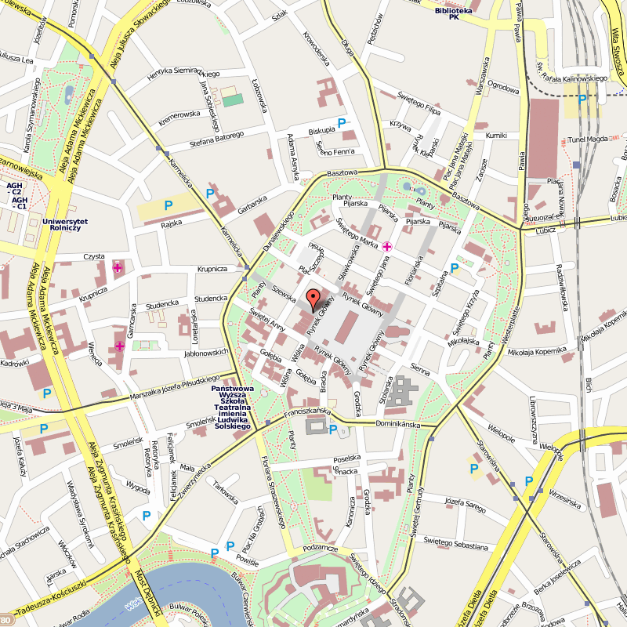

15.00 – 18.00 Royal Krakow – walking tour around the Old Town
(Meeting point: Flamingo hostel at 3 pm)
We will start on the Wawel Hill, for centuries the centre of power of the Polish state, with its magnificent renaissance Royal Castle (we see the State Chambers) and the Cathedral with the royal tombs, Sigismundus’ Bell and the crypt. The next step is Kanonicza - the oldest street in Cracow. Then Grodzka Street will lead us to the Bishop’s Palace and the Franciscan Church, where we will admire the exceptional stained glass windows and art nouveau art. Later we will walk around the Main Market Square - the biggest medieval square in Europe, with the Renaissance Cloth Hall (where famous stall shops with the souvenirs are) and St. Mary’s Basilica with the marvelous medieval altar. We will visit also the University Quarter, paying special attention to Collegium Maius - the oldest building of the Jagiellonian University.
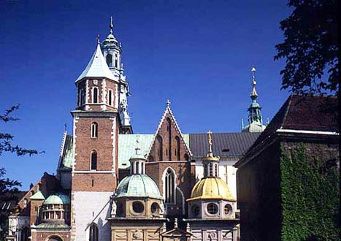
Entrance fees:
the Cathedral 10 PLN/adult, 5 PLN/student (paid for)
St. Mary's Church 6 PLN/adult , 4 PLN/student
Evening at leisure

Day 2: 18th June (Saturday)
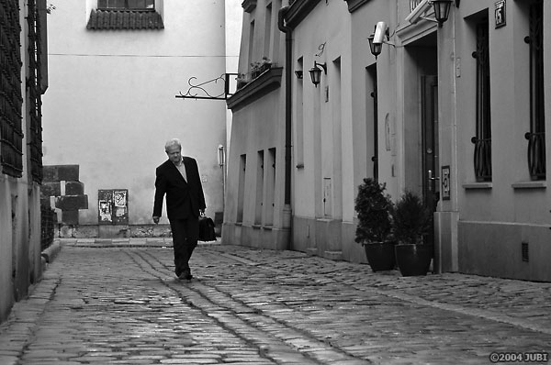
9.30 – 11.00 Jewish Krakow
(Meeting point: Flamingo hostel at 9.30 am)
During this tour we see Kazimierz, the former Jewish town, that has become world famous due to the film The Schindler's List that was made here by Steven Spielberg. We will follow Jozef’s Street, to see the courtyard filmed in the ‘Shindler’s List’ movie, which will take us to the New Square – the former Jewish trading center – now the students and the artists of Cracow spend their free time here. After seeing the Temple Synagogue, which served the modern Jews, Ciemna Street – a typical Jewish district street - will guide us to Szeroka Street - the heart of the former Jewish city. Here we will see Remuh Synagogue and Cemetery, Mykwah, Old Synagogue, Popper’s Synagogue and Helena Rubinstein’s birth place. Later we will go to the Galicia Jewish Museum to see the photographic exhibition showing the life and the heritage of the Jewish People in Poland.
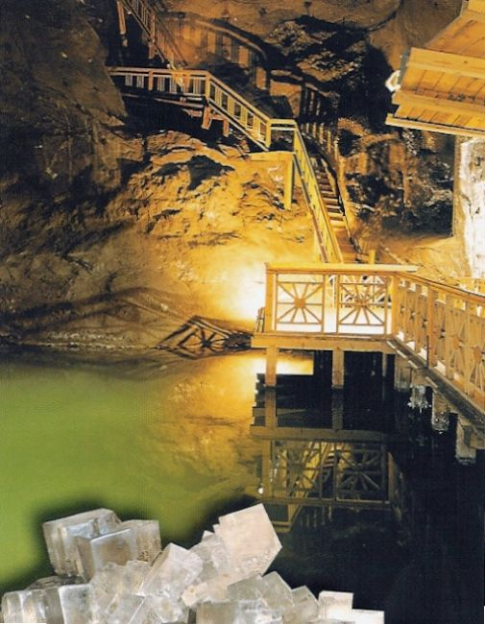
Entrance fees (suggested): Old Synagogue 5 PLN/adult, 3 PLN/student (paid for), Galicja Jewish Museum 12 PLN/adult, 7 PLN/student

11.30 – 13.30 Nowa Huta tour – we will do this tour by coach

15.15 – 15.45 transfer to Wieliczka
16.05 – 18.30 Salt Mine in Wieliczka (optional) http://www.kopalnia.pl/home.php?urlMain=2,1613,1,27,,&id_location=1&reloadMenu=true&level=-1&id_site=10000
This tour is ideal for all those tired of hot or cold weather or simply tired of traditional sightseeing.... The Royal Salt Mine in Wieliczka is a unique underground enormous complex of the tunnels, chambers and chapels, which dates back to the late 13th century. After 700 years of salt extraction it resembles an underground town. Situated on nine levels, the mine reaches 327m below the ground and hides about 3000 chambers. The tour will give you an opportunity of spending an unforgettable time exploring magnificent salt chambers, statues, underground lakes and chapels, including the biggest underground chapel made of salt in the world. In 1978 the Wieliczka Salt Mine was entered on the UNESCO World Heritage List.
After taking 372 steps down, we will follow the labyrinth of underground tunnels and chambers. The guide will tell you about the history of the mine and the daily life of the miners working in the depths of this salt mine. One of the chambers houses the 19th century Chapel of Saint Kinga, with the amazing decoration carved in salt, 135m below the ground you can have a break for a cup of coffee in the restaurant, some souvenir shopping, or mailing a postcard from the underground post office. Then a lift takes you back to the surface.
Entrance fee: The guide for the group will be paid by Masaryk University and the transportation by the bus to and from the place will be provided. You will however have to pay the entrance fee which amounts to 29 PLN/student. The minimum 15 people have to show an interest; otherwise you will have to go on your own.

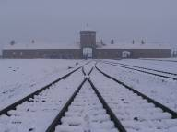
Day 3: 19th June (Sunday)
12:45 meeting in the hostel lobby

13.00 departure to Oswiecim

14.30 Arrival to Oswiecim

15.00 – 18.30 visit of the former Nazi concentration camps: Auschwitz and Auschwitz-Birkenau

18.30 departure from Oswiecim to Brno

Approx. 22.00 Arrival to Brno

Looking for further information?

http://www.krakow.pl/en/
http://www.krakow-info.com/
http://www.cojestgrane.pl/
http://inyourpocket.com/poland/krakow/en/
http://www.thevisitor.pl/
Suggestions for the evening:
Club Prezak
Club Faust
Lizzard King

Restaurants:
Pod Wawelem
Chlopskie jadlo
Selskie jadlo
Pod zamkiom
Polakowski – in Kazimierz
Jewish festival at the end of june

